Obsolete Terminology

📕 What is Obsolete Terminology
# Source: AI Source: Provided by: [Data Path: Persons Table -> ID Column: 1, Name_En Column: Motasem Essam] -> From: [Chatgpt (GPT-4-turbo)] on [7/31/2025]
Obsolete terminology refers to terms that are no longer in active use due to changes in knowledge, technology, culture, or standards. These terms may be outdated, replaced, or no longer relevant to modern contexts.

🧩 Key Characteristics:
# Source: AI Source: Provided by: [Data Path: Persons Table -> ID Column: 1, Name_En Column: Motasem Essam] -> From: [Chatgpt (GPT-4-turbo)] on [7/31/2025]
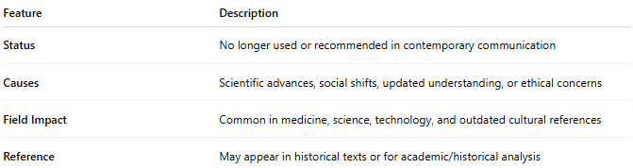
Feature | Description
Status | No longer used or recommended in contemporary communication
Causes | Scientific advances, social shifts, updated understanding, or ethical concerns
Field Impact | Common in medicine, science, technology, and outdated cultural references
Reference | May appear in historical texts or for academic/historical analysis

🧠 Who Uses It (Rarely)?
# Source: AI Source: Provided by: [Data Path: Persons Table -> ID Column: 1, Name_En Column: Motasem Essam] -> From: [Chatgpt (GPT-4-turbo)] on [7/31/2025]
- Historians
- Archivists
- Linguists
- Researchers in historical or comparative studies

💡 Examples:
# Source: AI Source: Provided by: [Data Path: Persons Table -> ID Column: 1, Name_En Column: Motasem Essam] -> From: [Chatgpt (GPT-4-turbo)] on [7/31/2025]
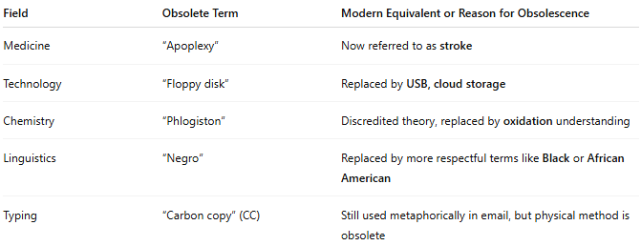
Field | Obsolete Term | Modern Equivalent or Reason for Obsolescence
Medicine | “Apoplexy” | Now referred to as stroke
Technology | “Floppy disk” | Replaced by USB, cloud storage
Chemistry | “Phlogiston” | Discredited theory, replaced by oxidation understanding
Linguistics | “Negro” | Replaced by more respectful terms like Black or African American
Typing | “Carbon copy” (CC) | Still used metaphorically in email, but physical method is obsolete

🆚 Compared to Other Types:
# Source: AI Source: Provided by: [Data Path: Persons Table -> ID Column: 1, Name_En Column: Motasem Essam] -> From: [Chatgpt (GPT-4-turbo)] on [7/31/2025]
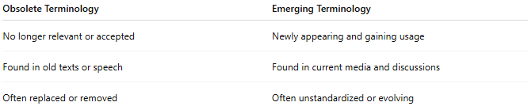

Obsolete Terminology | Emerging Terminology
No longer relevant or accepted | Newly appearing and gaining usage
Found in old texts or speech | Found in current media and discussions
Often replaced or removed | Often unstandardized or evolving

